o
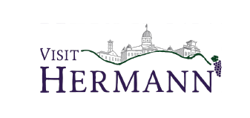

Hermann Attractions

Visitor Center Open – 8 to 8
301 Wharf Street (at Amtrak Station)

VisitHermann.com 573-789-0771

Parking Available at:
Riverfront Park, Gutenberg St,
2nd & 5th Street, & Engemann Memorial Park
________________________________________

Deutschheim State Historic Site
101 West 2nd Street
- Gift Shop & Grounds open daily 10 – 4
- George Husmann Exhibit, Saturday 10 - 4
- Guided Tours 10, 12:30, & 2:30, $5 adult, $3 kids

Historic Hermann Museum
4th & Schiller Street
- Open Fri & Sat 10 -4, Sun 12 – 4
- Tour Museum & Gift Shop

Hermann Farm
526 East 1st Street
- Open Fri 11-5, Sat 12-5
- Distillery Tours – Fri 2:30pm & Sat 10:30am
- Carriage Rides – Sat - 1pm & 2pm
- Register @ hermannfarm.org

City of Hermann Caboose Museum
East 1st Street & Gutenberg
- Open daily 8 - 8
- Self-guided exhibits and displays of Missouri railroad history

Stone Hill Winery Cellar Tours
1110 Stone Hill Highway
- Open Fri & Sat 10 – 5pm, Sun 11 – 4pm
- Cellar Tours Daily, register at winery

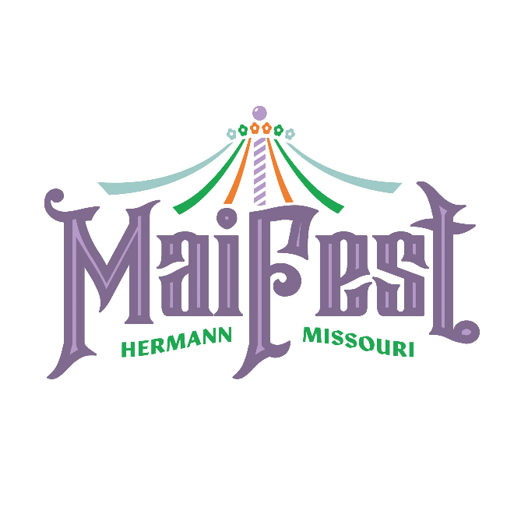

Saturday, May 16
Volksplatz – Street Market 10 am – 5 pm
- Located along Schiller St. & 3rd St.
- Vendors, food, crafts, and more!

Kids Activities 10 am – 2 pm
- Bounce Houses, Face Painting, Bubble Bus & Monkey Bus

Maifest Dance & Music 12 pm – 4 pm
FestHalle, 1st Street
- Food & Drink available for purchase
- German music by The Loehnig German Band

Other Saturday Events:

Maifest at Stone Hill 10am – 5pm
Live music, wine tastings, & cellar tours

Maifest at Copper Mule 10am – 6pm
Live German music, German beer & food

Insider Tasting Experience
At Hermannhof Winery 12pm – 3pm
Guided wine sampling of 6 Hermannhof wines

Saturday Live Music & Entertainment:

Schiller Street
Wurst Bavarian Band 10am-1pm
Gasconade River Band 2 - 5pm
Adam Puchta Winery
Pilot Grove 10am – 2pm
Blake Gardner Solo 3 – 6pm
Hermannhof Winery
Twice Baked 12 – 4pm
Stone Hill Winery
Pocket Change Blues Band 1 – 5pm

Tin Mill Brewery
Project 324 5 – 8pm

1837 Cellar Bar
Roommade 6 – 10pm

Karaoke at The 413 7pm - 12am

